Advantzware Upgrade from Ver. 4.10 to 5.0

This document will give the details of all the tasks needs to be performed for the upgrade process.

The upgrade process is divided into following tasks

- Checking database for the standards and integrity
- Getting the incremental data definition file (delta.df)
- Copy databases to new version
- Create services for new version databases and start databases on the server
- Create icons for new version
- Applying incremental df file to databases
- Moving programs from development to test environment
- Compiling the codes
- Changing the helpdesk program to work with new version

Checking database for the standards and integrity

Following things needs to be checked in the development environments for the new tables.
- All the new tables must have rec_key field
- All the new tables have create, write and delete trigger defined.

Procedure to /checking creating triggers.

Open data dictionary -> select the database -> select the new table -> Click on Table properties.
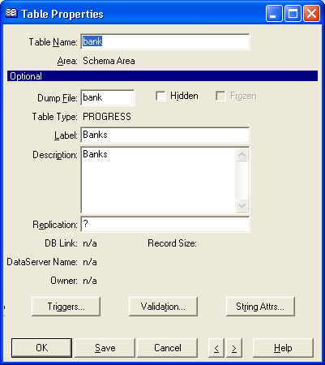

Click on Triggers
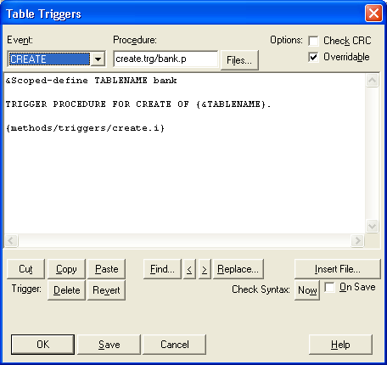

Make sure CREATE, DELETE and WRITE triggers are defined, Check CRC is not checked and Override is checked.
If these triggers are not defined create the triggers for the tables. Make sure that the trigger procedure name is same as table name.

Example for Triggers

- Create
&Scoped-define TABLENAME ed

TRIGGER PROCEDURE FOR CREATE OF {&TABLENAME}.

{methods/triggers/create.i}

- Delete
&Scoped-define ACTION DELETE
&Scoped-define DBNAME PDBNAME('ASI')
&Scoped-define TABLENAME ed

TRIGGER PROCEDURE FOR DELETE OF {&TABLENAME}.

{methods/triggers/delete.i}

- Write

&Scoped-define ACTION UPDATE
&Scoped-define DBNAME PDBNAME('ASI')
&Scoped-define TABLENAME ed

TRIGGER PROCEDURE FOR WRITE OF {&TABLENAME} OLD BUFFER old-{&TABLENAME}.

{methods/triggers/write.i}

Trigger procedure locations:
z:\asi_gui9\pco410\create.trg
z:\asi_gui9\pco410\write.trg
z:\asi_gui9\pco410\delete.trg

Note: Repeat the process for all the new tables in all 7 databases.

Getting the incremental data definition file (delta.df)

There are total 7 Databases.
- Three main databases asi, asihelp and nosweat
- Four addon databases emptrack, jobs, nosweat and rfq

Database Location :
- Development environment
Main databases Y:\asi_gui99\db410
Addon Databases Y:\asi_gui99\db410\addon
- Test Environment
Main database Y:\asi9test\db410
Addon Databases Y:\asi9test\db410\addon

Identify the databases which got changed between the version 4.10 and Version 5.0.
( In case of version 5.0 only one database got changed which is asi )

Steps to create delta.df’s

- Run the development icon from the desktop
- 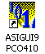

- Login as nosweat and no password. You are connecting to nosweat database.

- In the procedure editor type command – Run nosweat. Login as nosweat and password blank. Advantzware software will run. Click on exit to come out of the software. This will take you back to procedure editor. At this point you are connected to asi, nosweat and asihelp databases.

- Connect to databases asi, asihelp and nosweat from test environment with logical database name asi-test, asihelp-test and nosweat-test respectively.

- Goto Data Admin from the Tools menu in Procedure editor

- Select working database – asi. From Admin ->Dump Data and definations->Create Incremental .df file.
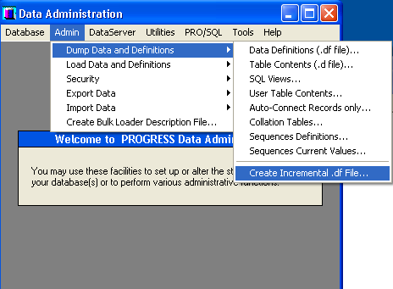

When prompted choose asi-help to compare against.
Store the incremental .df file file in

z:\asi_gui9\db\db_delta

Copy the databases for new version

Main database Y:\asi9test\db410 Copy to y:\asi9test/db500
Addon Databases Y:\asi9test\db410\addon Copy to Y:\asi9test\db410\addon

Create services for new version databases and start databases on the server. Also update services file on clients.

Create icons for new version

Create development and test icons for the new version.
Copy it from Version 410 to 500 and change the references.

Applying incremental df file to databases

Connect to test environment for new version using the test icons.

From the Tools menu -> Data Administration

Select the working database from Database menu for which you want to apply the incremental df file (delta.df) .

From admin menu -> Load Data and definations -> Data Defination(.df file)

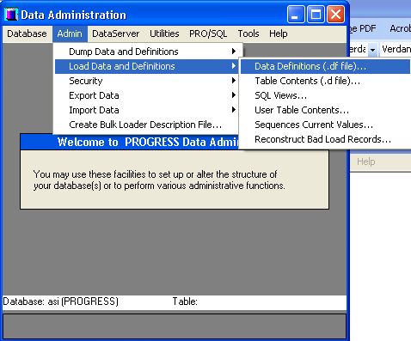

Choose the appropriate incremental df file for updating the database.

Repeat the process for all the databases if necessary.

Note: This process should be used for the databases which were changed between the versions. Otherwise it is not necessary.

Moving programs from development to test environment

- Create file directory structure for new version

Development : Source program z:\asi_gui9\pco500

Test : z:\asi9test\pco500
Z:\asi9test\rco500
Z:\asi9test\patch\pco500
Z:\asi9test\patch\rco500

- Move all the code from test PCO410 to PCO500
- Move al the codes from test PC410/patch to PCO500/patch

- Create start500.p under z:\asi9test.p

- Compile all programs from Test .
custom/compiler.w
Change path for new version(from 410 to 500)
- Copy all rco500 from test to ship and blank out all patch rco500 and pco500
- Helpdesk Compiler is on the web server. Change the icon for new version and make a copy of .p and change all the references for new version

Compiler tool – Compiler tool from web server
Pco500\hdcomp500.p, hdcompiler.w

